UML Diagrams :

Use Case Diagram
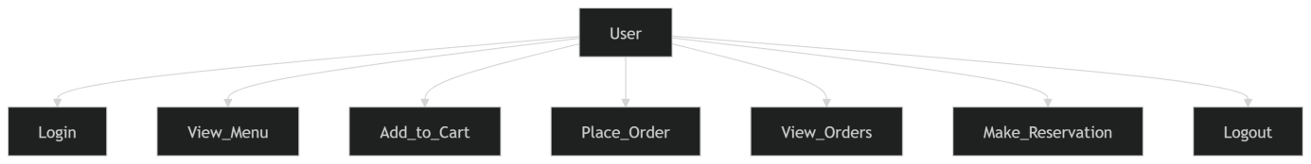

Sequence Diagram
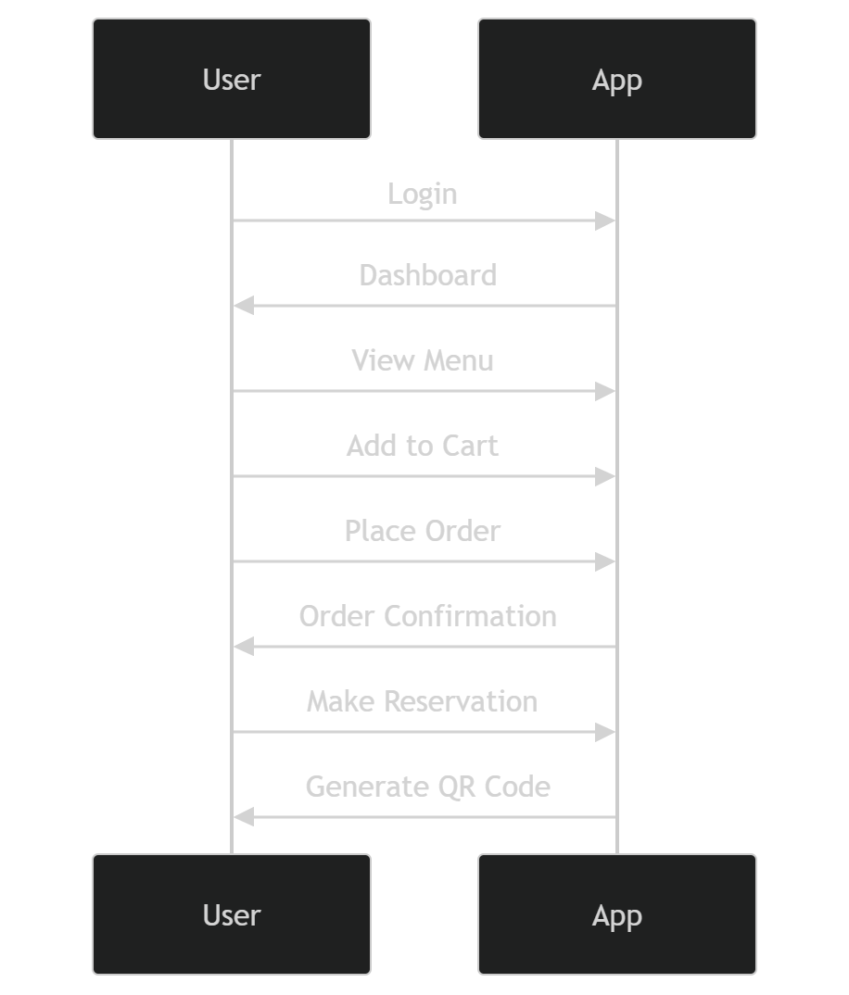

Class Diagram
